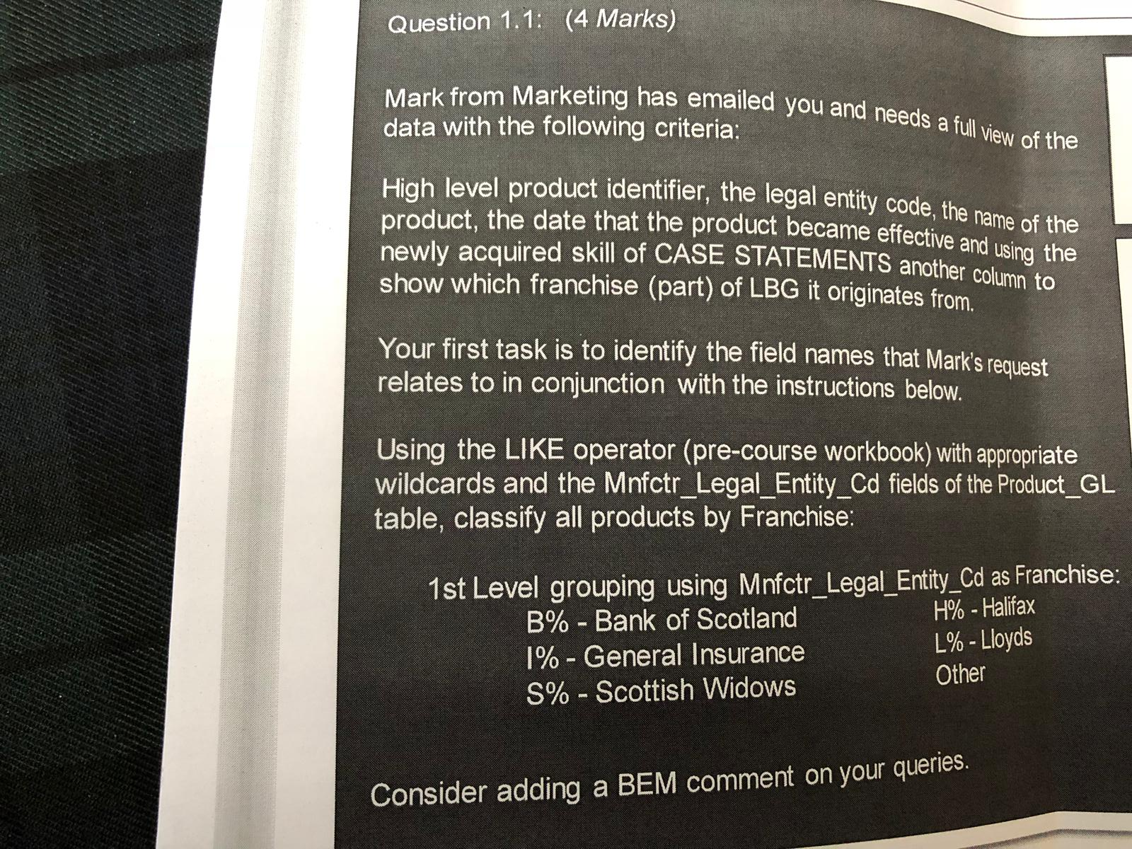

/*Below query selects the required columsn from Product_GL table and Franchise column is derived from Mnfctr_Legal_Entity_Cd based on the starting letter of the Code*/

SELECT PROD_ID, LEGAL_ENTITY_CODE,PROD_NAME,PROD_EFFECTIVE_DATE,

CASE

WHEN MNFCTR_LEGAL_ENTITY_CD LIKE ‘B%’ THEN ‘Bank Of Scotland’

WHEN MNFCTR_LEGAL_ENTITY_CD LIKE ‘I%’ THEN ‘General Insurance’

WHEN MNFCTR_LEGAL_ENTITY_CD LIKE ‘S%’ THEN ‘Scottish Widows’

WHEN MNFCTR_LEGAL_ENTITY_CD LIKE ‘H%’ THEN ‘Halifax’

WHEN MNFCTR_LEGAL_ENTITY_CD LIKE ‘L%’ THEN ‘Lloyds’

ELSE ‘Other’

END AS FRANCHISE

FROM PRODUCT_GL



SELECT CASE

WHEN MNFCTR_LEGAL_ENTITY_CD LIKE ‘B%’ THEN ‘Bank Of Scotland’

WHEN MNFCTR_LEGAL_ENTITY_CD LIKE ‘I%’ THEN ‘General Insurance’

WHEN MNFCTR_LEGAL_ENTITY_CD LIKE ‘S%’ THEN ‘Scottish Widows’

WHEN MNFCTR_LEGAL_ENTITY_CD LIKE ‘H%’ THEN ‘Halifax’

WHEN MNFCTR_LEGAL_ENTITY_CD LIKE ‘L%’ THEN ‘Lloyds’

ELSE ‘Other’

END AS FRANCHISE, COUNT(*) AS NUM_OF_PRODUCTS

FROM PRODUCT_GL

GROUP BY FRANCHISE

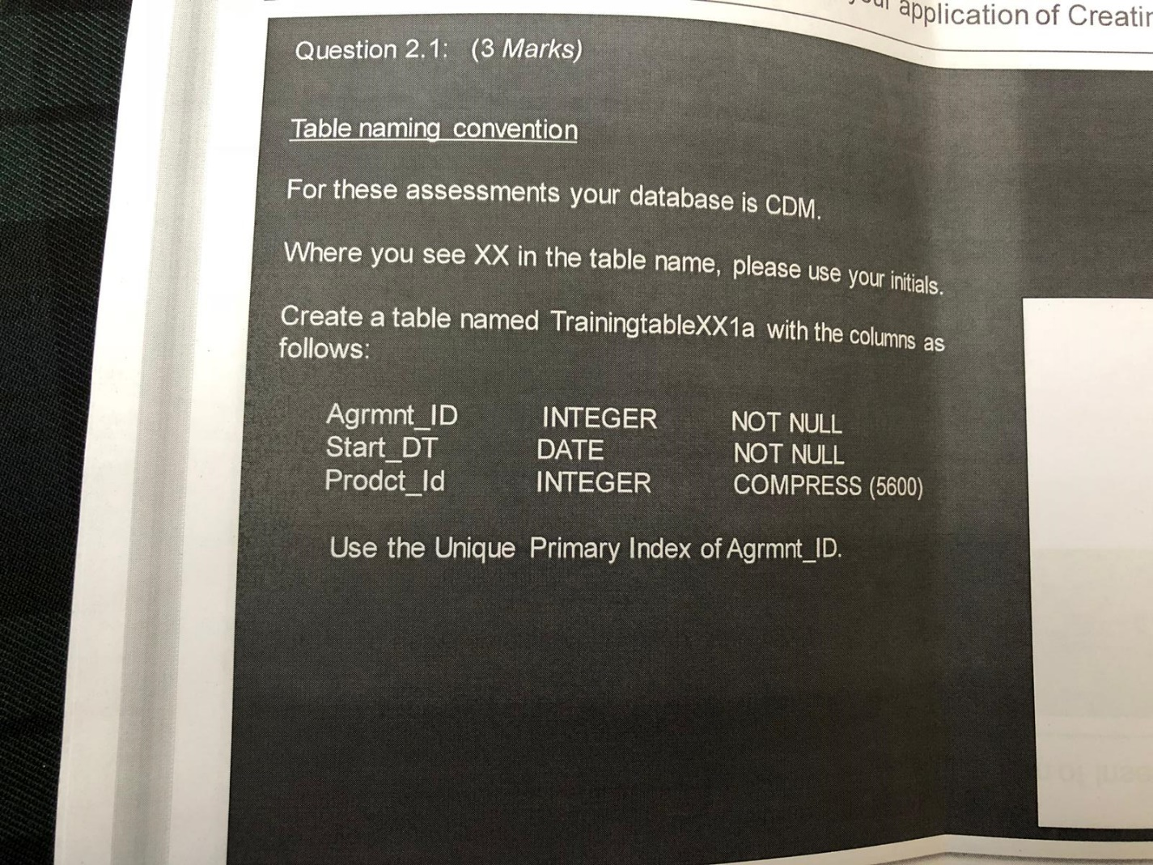

CREATE SET TABLE CDM.TrainingtableEO1a, FALLBACK (

Agrmnt_ID INTEGER NOT NULL,

Start_DT DATE FORMAT ‘YYYY-MM-DD’ NOT NULL,

Prodct_Id INTEGER COMPRESS(5600)

)

UNIQUE PRIMARY INDEX (Agrmnt_ID);

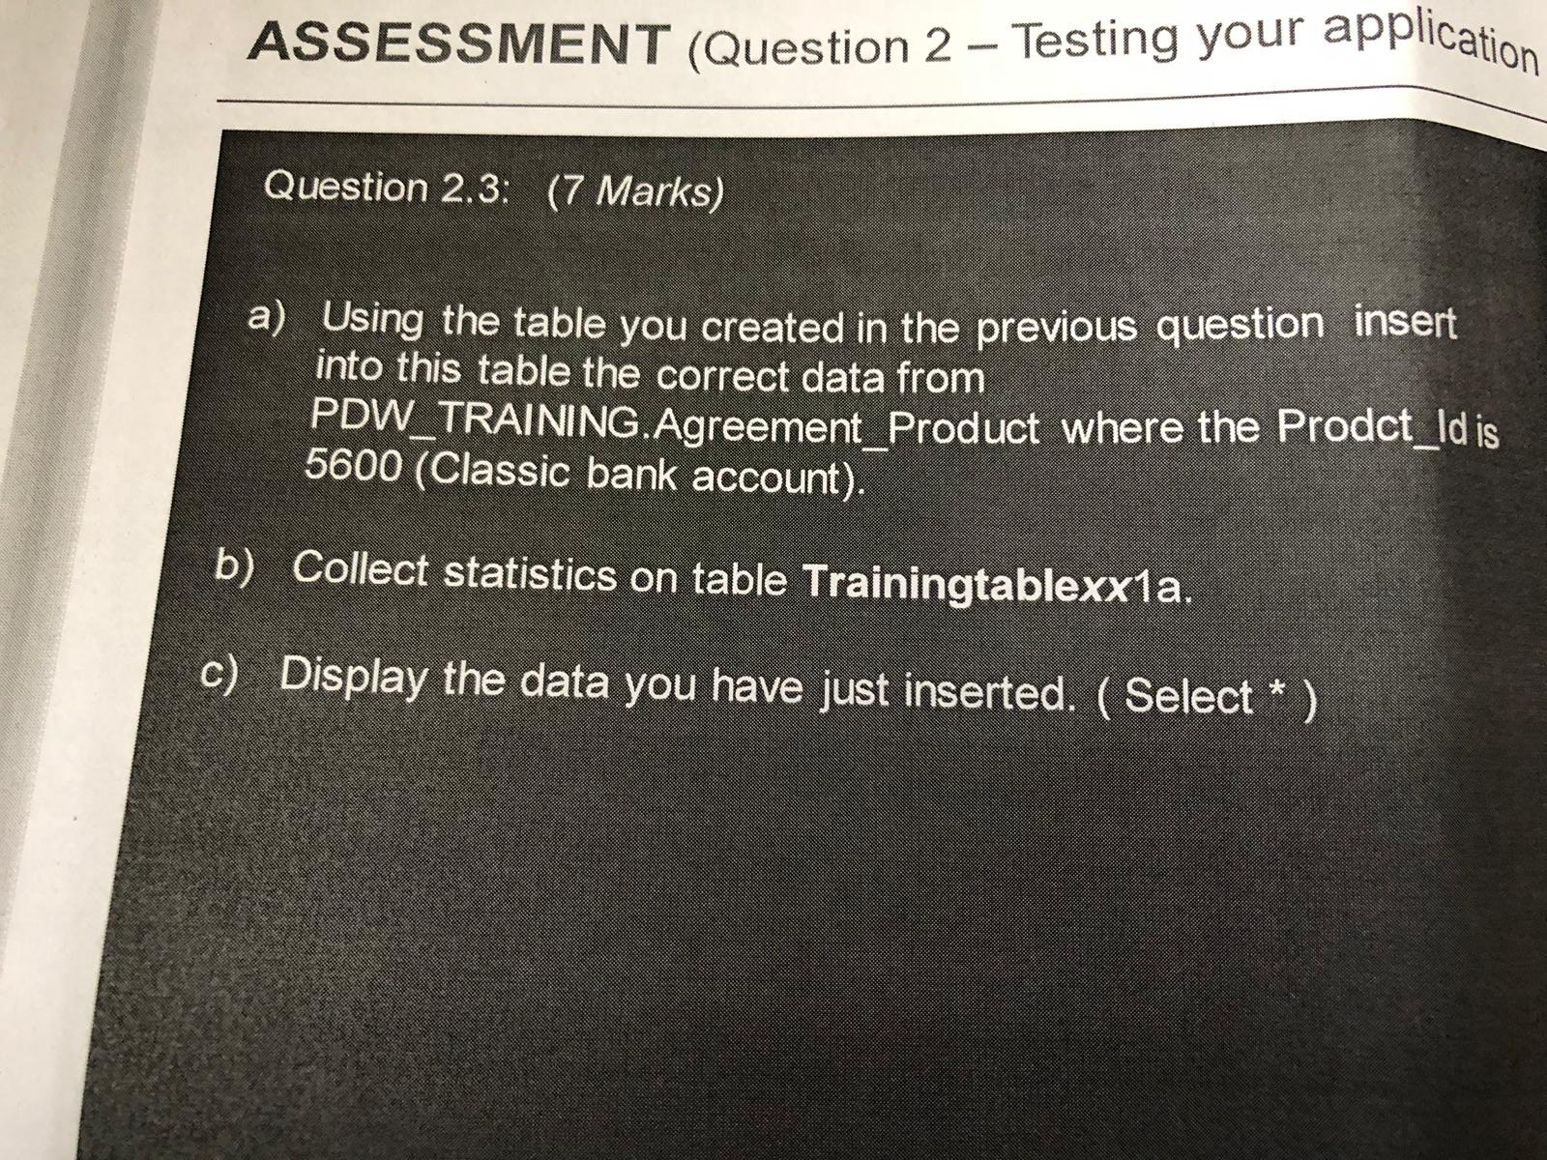

1. INSERT INTO CDM.TrainingtableEO1a SELECT Agrmnt_ID,Start_DT,Prodct_Id FROM PDW_TRAINING.Agreement_PRODUCT WHERE Prodct_ID=5600;
2. To Collect statistics on the table CDM.TrainingtableEO1a we can use the below query:

COLLECT STATISTICS ON CDM.TrainingtableEO1a;

After collecting to view the statistics we can use below query:

HELP STATISTICS CDM.TrainingtableEO1a;

1. Displaying the data we can use below query:

SELECT * FROM CDM.TrainingtableEO1a;

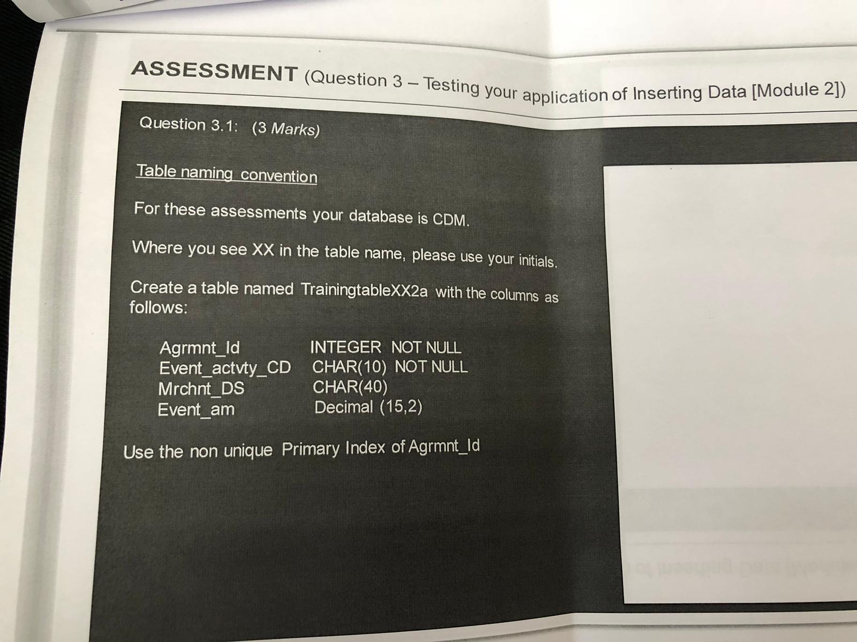

CREATE SET TABLE CDM.TrainingtableEO2a, FALLBACK (

Agrmnt_ID INTEGER NOT NULL,

Event_actvty_CD CHAR(10) NOT NULL,

Mrchnt_DS CHAR(40),

Event_am DECIMAL(15,2)

)

PRIMARY INDEX (Agrmnt_ID);/*Creates a Non-Unique Index*/

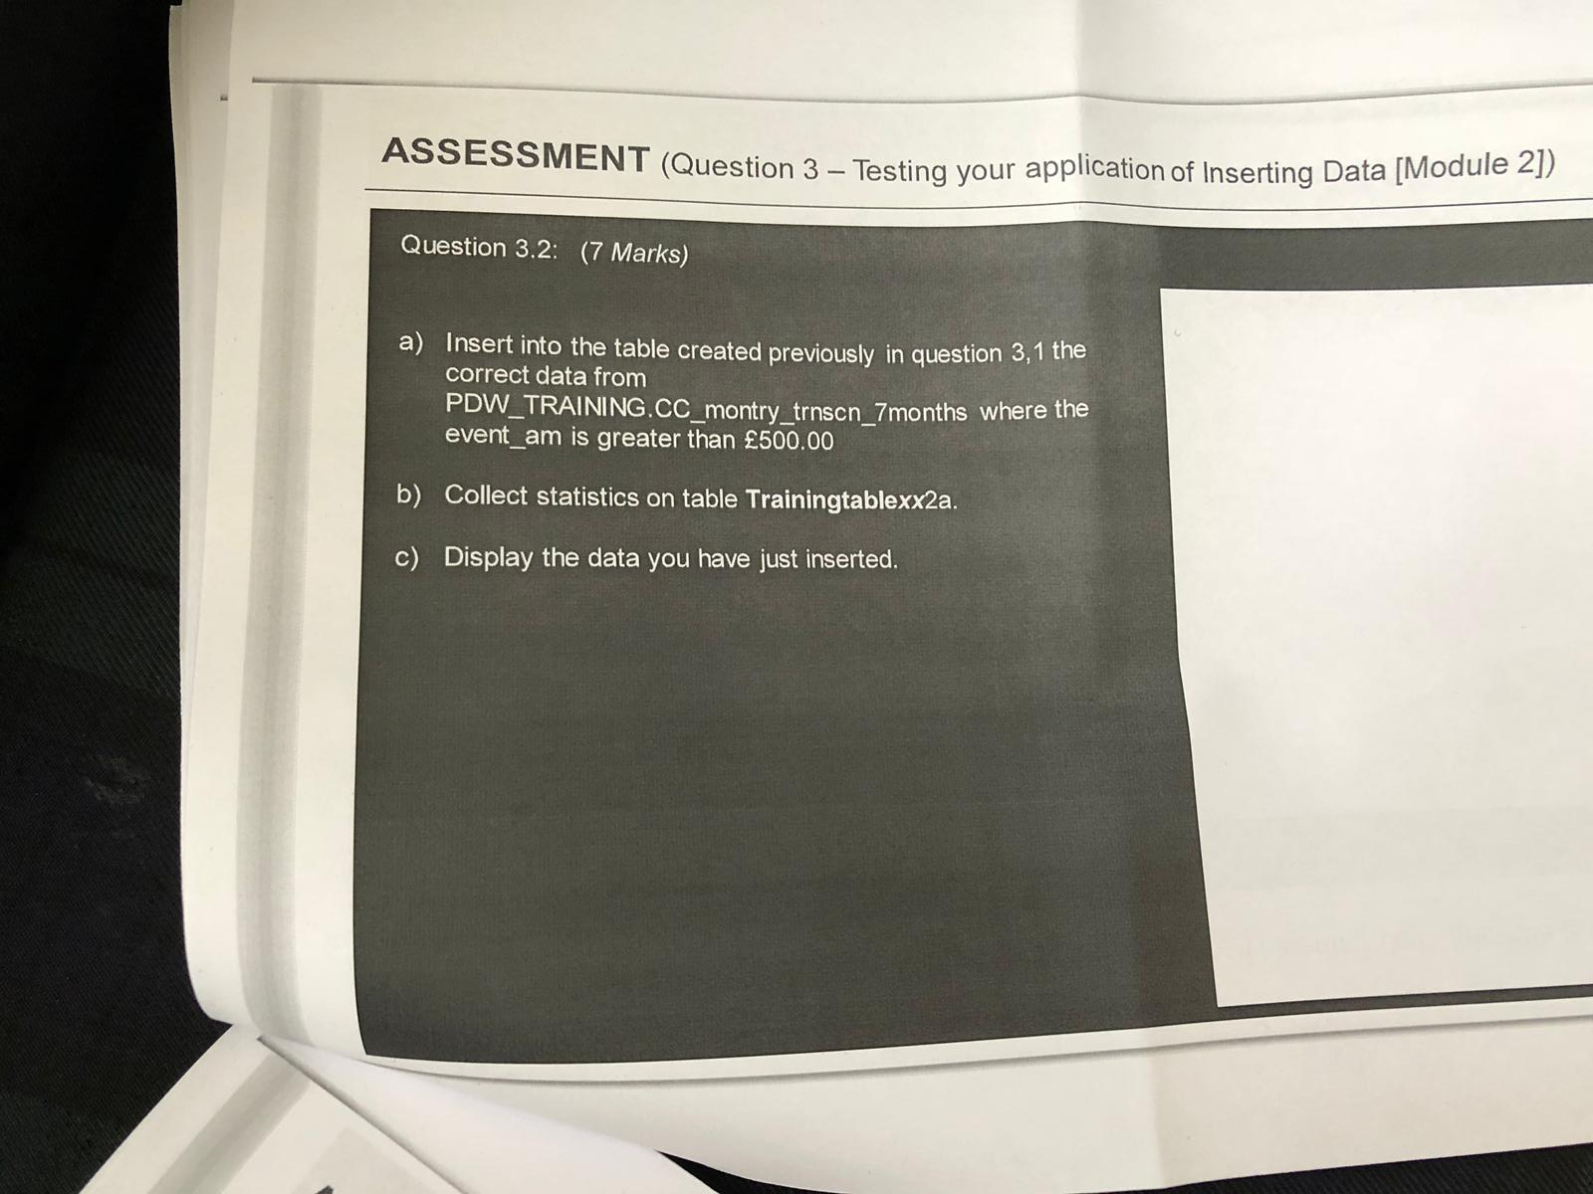

1. INSERT INTO CDM.TrainingtableEO2a SELECT Agrmnt_ID, Event_actvty_CD, Mrchnt_DS , Event_am FROM PDW_TRAINING.CC_montry_trnscn_7months WHERE event_am > 500;
2. To Collect statistics on the table CDM.TrainingtableEO2a we can use the below query:

COLLECT STATISTICS ON CDM.TrainingtableEO2a;

After collecting to view the statistics we can use below query:

HELP STATISTICS CDM.TrainingtableEO2a;

1. Displaying the data we can use below query:

SELECT * FROM CDM.TrainingtableEO2a;

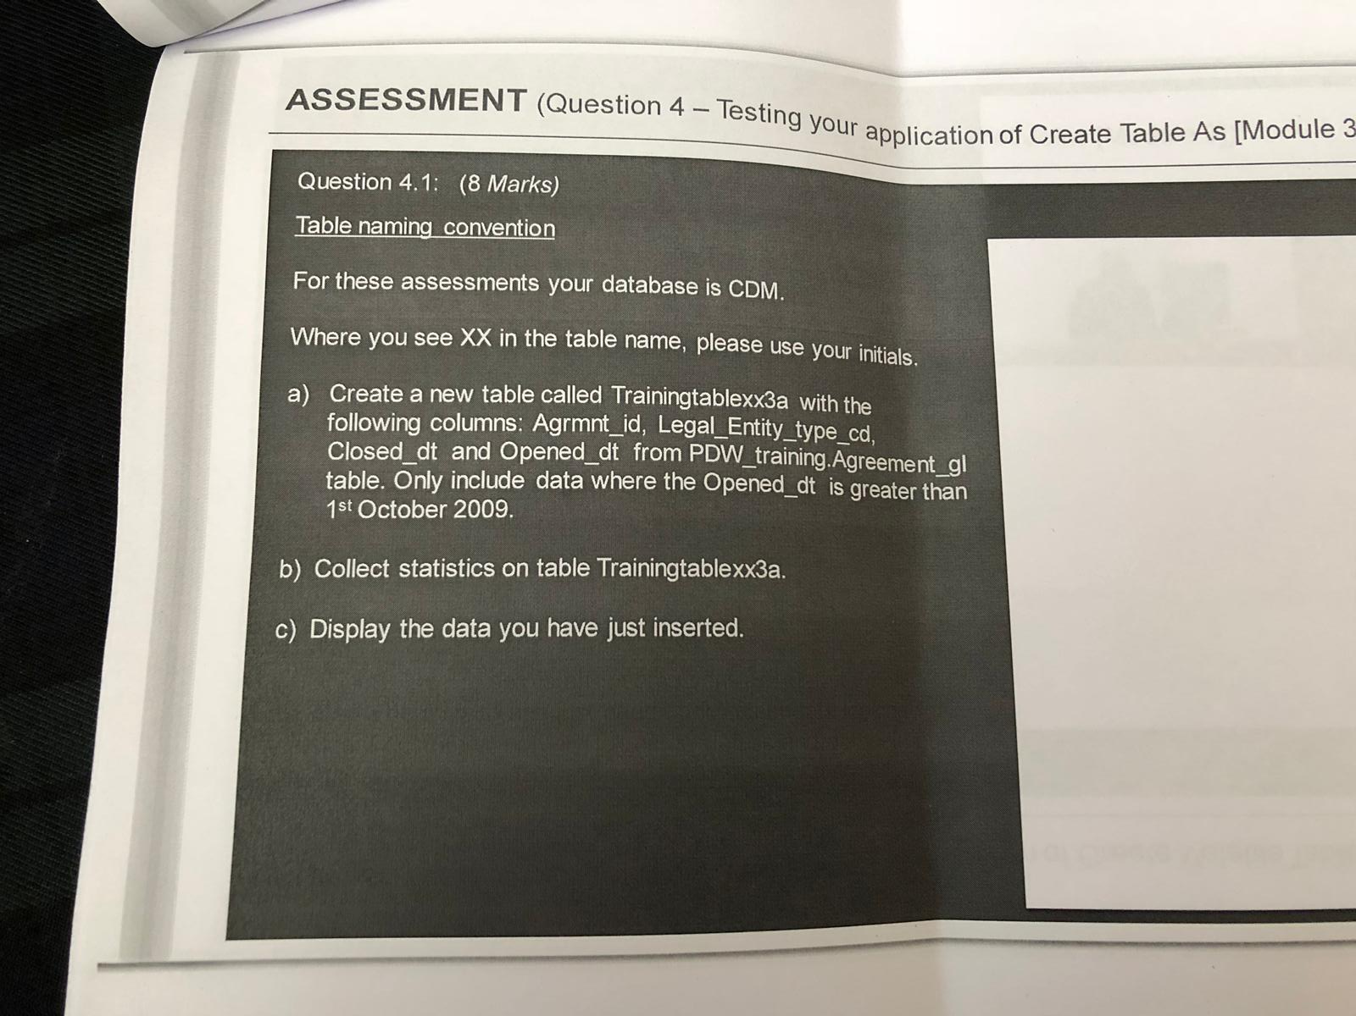

1. CREATE TABLE CDM.TrainingtableEO3a AS (

SELECT Agrmnt_id, Legal_Entity_type_cd, Closed_dt, Opened_dt FROM PDW_training.Agreement_gl) WITH NO DATA;

INSERT INTO CDM.TrainingtableEO3a SELECT Agrmnt_id, Legal_Entity_type_cd, Closed_dt, Opened_dt FROM PDW_training.Agreement_gl WHERE Opened_dt > ‘2009-10-01’;

1. To Collect statistics on the table CDM.TrainingtableEO3a we can use the below query:

COLLECT STATISTICS ON CDM.TrainingtableEO3a;

After collecting to view the statistics we can use below query:

HELP STATISTICS CDM.TrainingtableEO3a;

1. Displaying the data we can use below query:

SELECT * FROM CDM.TrainingtableEO3a;

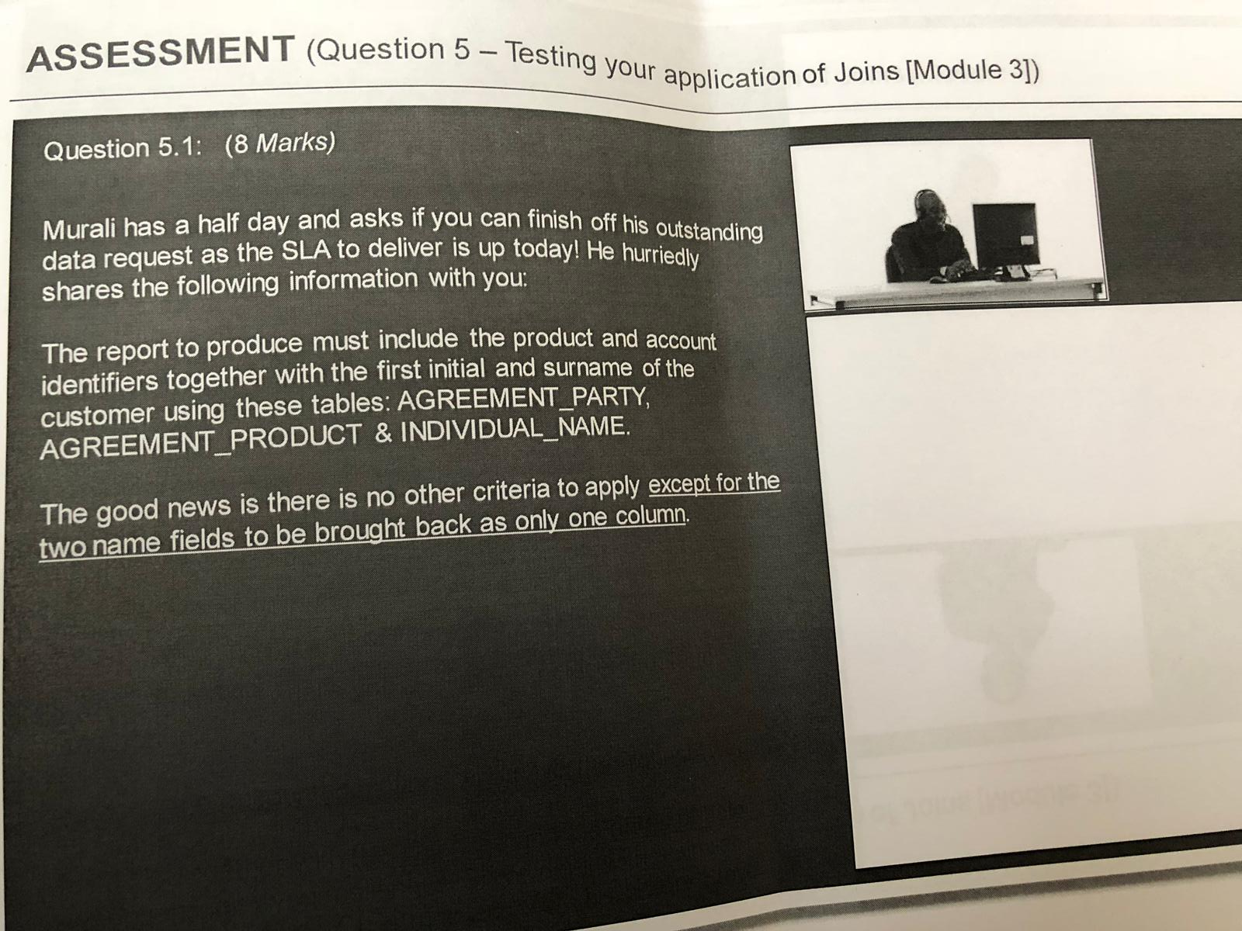

SELECT B.PRODUCT_ID, A.ACCOUNT_ID, C.FIRST_INITIAL||C.SURNAME

FROM AGREEMENT_PARTY A, AGREEMENT_PRODUCT B, INDIVIDUAL_NAME C

WHERE A.PRODUCT_ID = B.PRODUCT_ID

AND A.ACCOUNT_ID = C.ACCOUNT_ID;

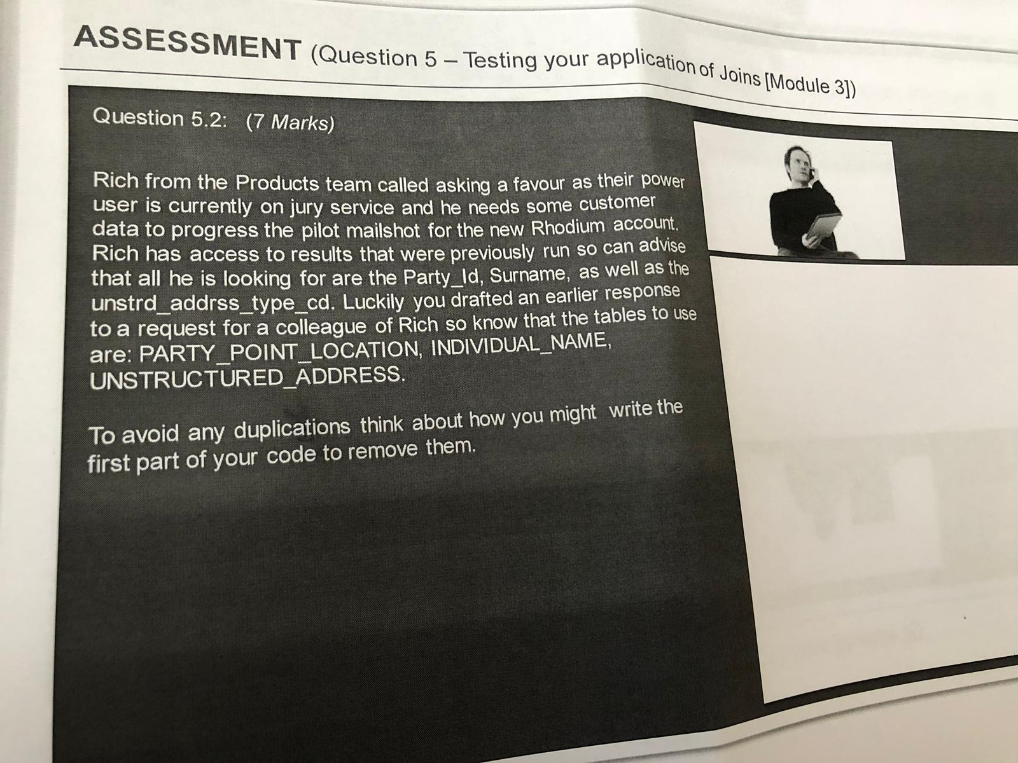

SELECT DISTINCT A.Party_ID, B.Surname, C.unstrd_addrss_type_cd

FROM PARTY_POINT_LOCATION A, INDIVIDUAL_NAME B, UNSTRUCTURED_ADDRESS C

WHERE A.Party_ID = B.Party_ID

AND B. unstrd_addrss_type_cd = C. unstrd_addrss_type_cd;

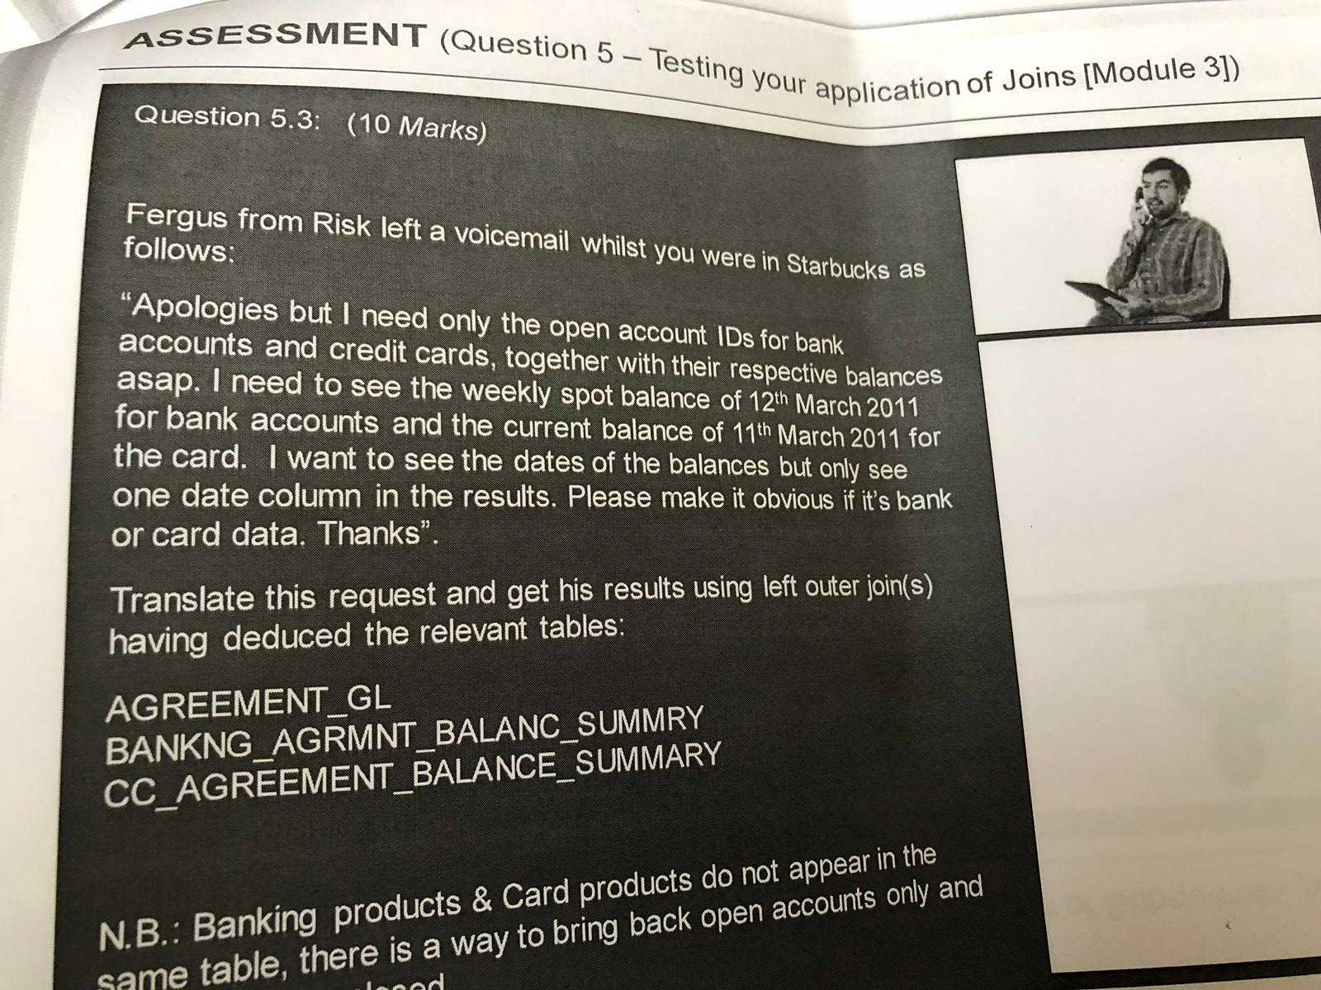

SELECT A.ACCOUNT_ID, COALESCE(A.WEEKLY_SPOT_BALANCE, B.CURRENT_BALANCE) AS BALANCE,

COALESCE(A.DATE, B.DATE) AS DATE FROM AGREEMENT_GL A LEFT JOIN BANKING_AGRMNT_BALANC_SUMMRY B

ON (A.ACCOUNT_ID = B.ACCOUNT_ID

AND A.ACCOUNT_STATUS=”OPEN”

AND B.DATE = ‘2011-03-12’) LEFT JOIN CC_AGREEMENT_BALANCE_SUMMARY C

ON (A.ACCOUNT_ID = C.ACCOUNT_ID

AND A.ACCOUNT_STATUS=’OPEN’

AND C.DATE = ‘2011-03-11’);

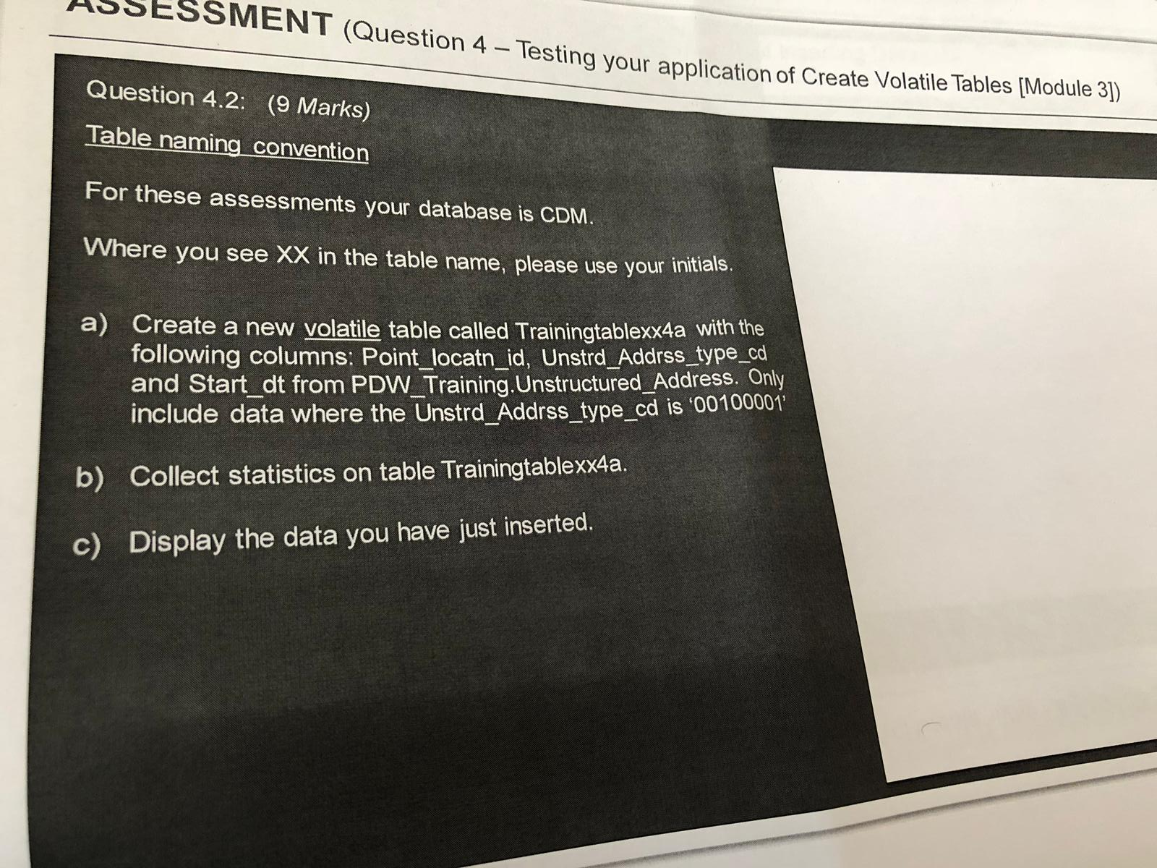

1. CREATE VOLATILE TABLE CDM.TrainingtableEO4a AS (SELECT Point_locatn_id, Unstrd_Addrss_type_cd, Start_dt FROM PDW_Training.Unstructured_Address WHERE Unstrd_Adrss_typde_cd = ‘00100001’) WITH DATA ON COMMIT PRESERVE ROWS;
2. To Collect statistics on the table CDM.TrainingtableEO4a we can use the below query:

COLLECT STATISTICS ON CDM.TrainingtableEO4a;

After collecting to view the statistics we can use below query:

HELP STATISTICS CDM.TrainingtableEO4a;

1. Displaying the data we can use below query:

SELECT * FROM CDM.TrainingtableEO4a;

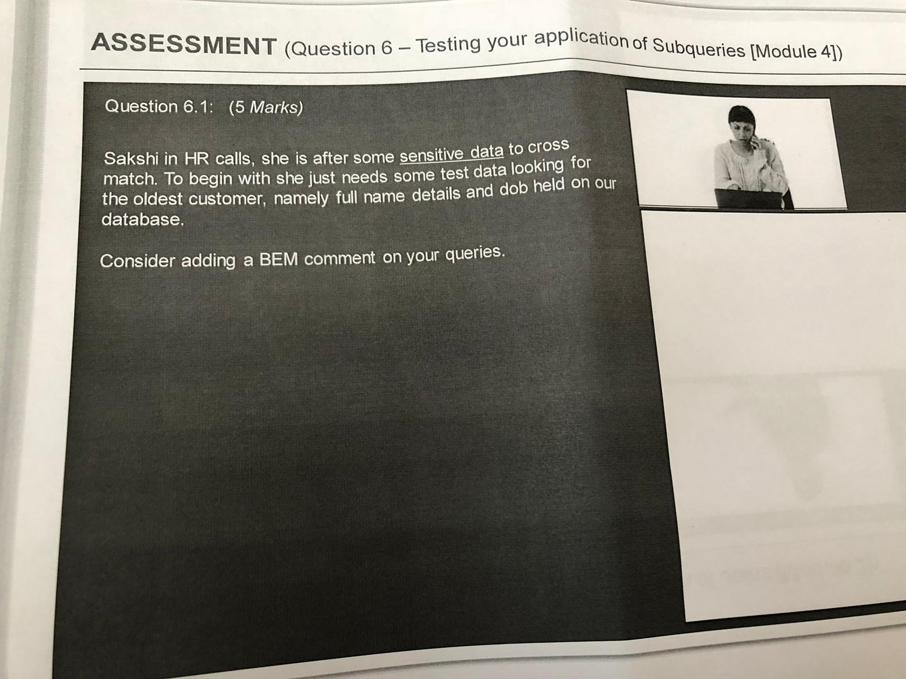

/*To Select the Oldest Customer from CUSTOMER database we can use minimum of DOB in the select query*/

SELECT * FROM CUSTOMER WHERE DOB = (SELECT MIN(DOB) FROM CUSTOMER); /*The sub query returns the minimum of the DOB value from the CUSTOMER table*/



/*To Select the Oldest and Youngest Customer from CUSTOMER database we can use minimum and Maximum of DOB in the select query*/

SELECT * FROM CUSTOMER WHERE DOB IN ( SELECT MIN(DOB) FROM CUSTOMER

UNION SELECT MAX(DOB) FROM CUSTOMER); /*The sub query returns the minimum of the DOB value and maximum of DOB value from the CUSTOMER table*/

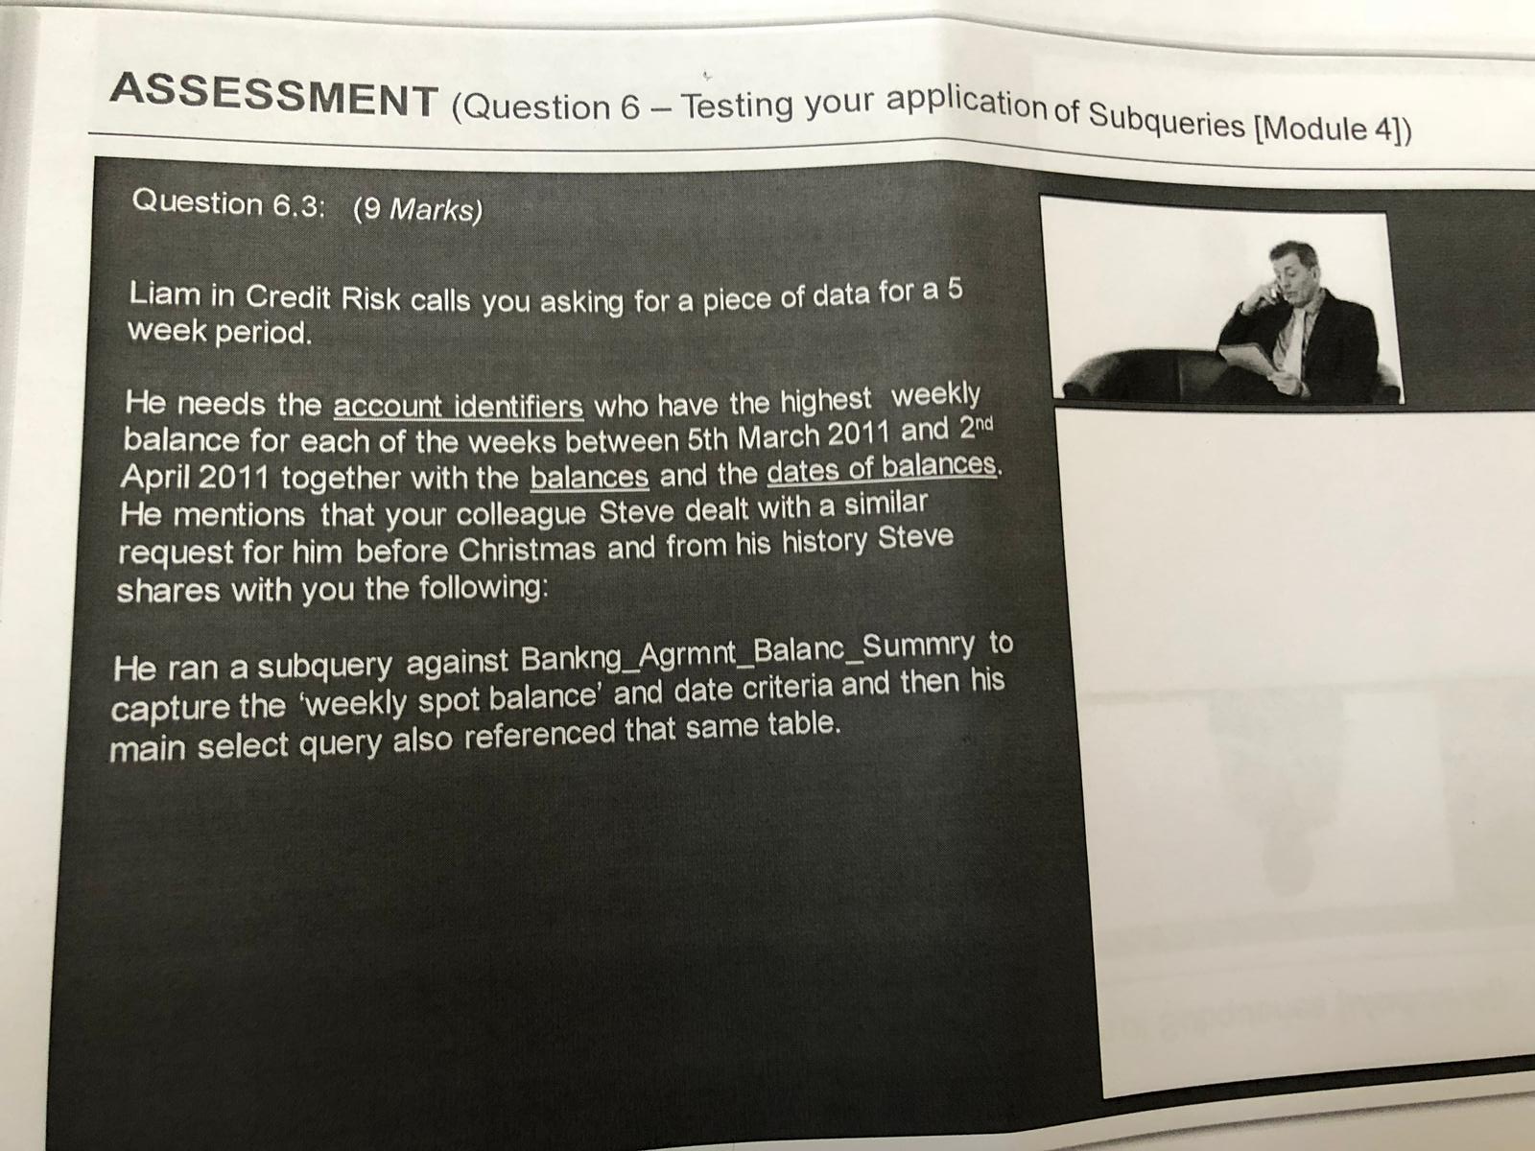

SELECT A.ACCOUNT_ID, A.WEEKLY_SPOT_BALANCE, A.DATE FROM BANKNG_AGRMNT_BALANC_SUMMRY A

WHERE A.WEEKLY_SPOT_BALANCE IN (SELECT MAX(WEEKLY_SPOT_BALANCE) FROM BANKNG_AGRMNT_BALANC_SUMMRY B WHERE A.DATE = B.DATE)

AND A.DATE BETWEEN ‘2011-03-05’ AND ‘2011-04-02’;

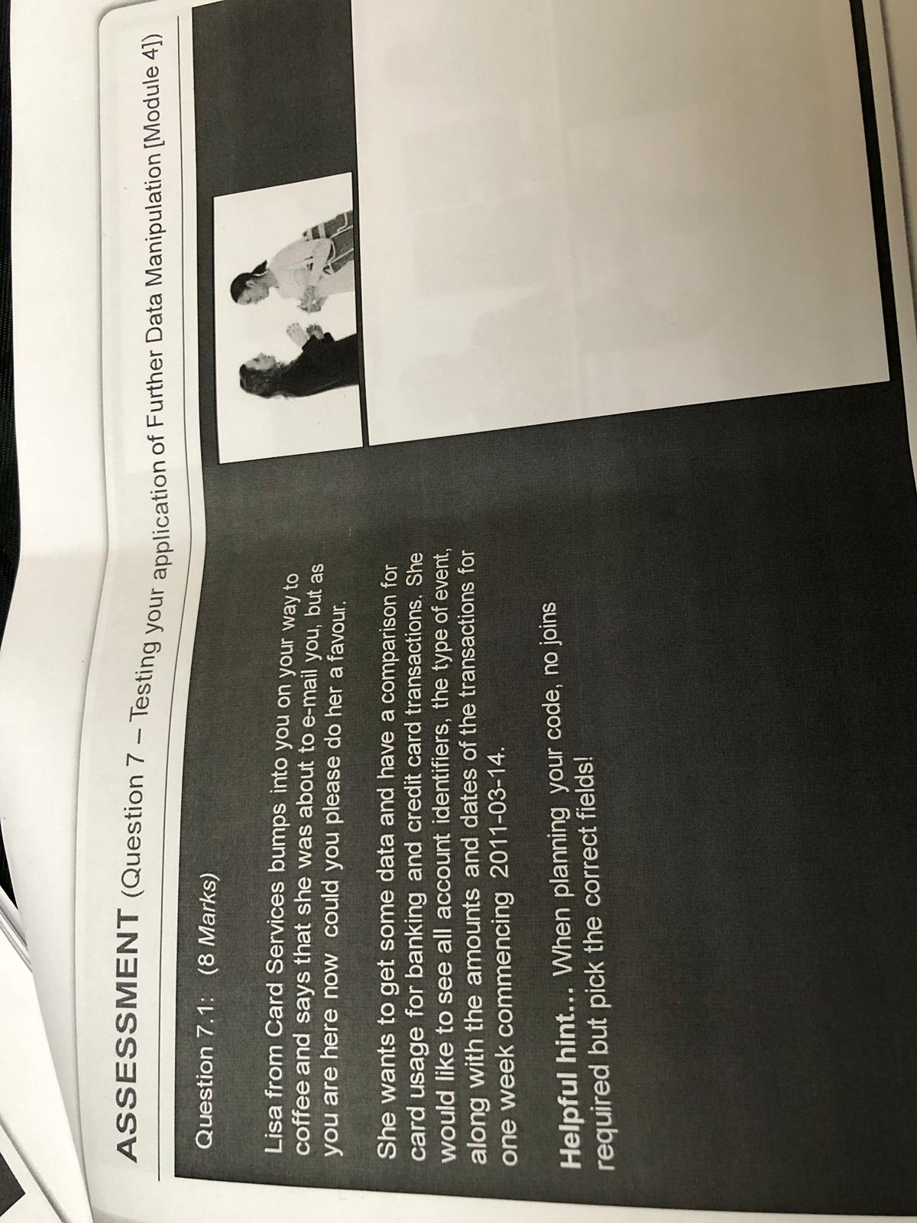

SELECT ACCOUNT_ID, EVENT_TYPE, AMOUNT, DATE FROM BANKING_TRANS WHERE DATE BETWEEN ‘2011-03-14’ AND ‘2011-03-21’

UNION ALL

SELECT ACCOUNT_ID, EVENT_TYPE, AMOUNT, DATE FROM CC_TRANS WHERE DATE BETWEEN ‘2011-03-14’ AND ‘2011-03-21’;

/*The above query first selects data from Banking transactions table for one week with required fields and then it combines data from second table that is of Credit Card Transactions with required fields and then combines with UNION ALL operator*/

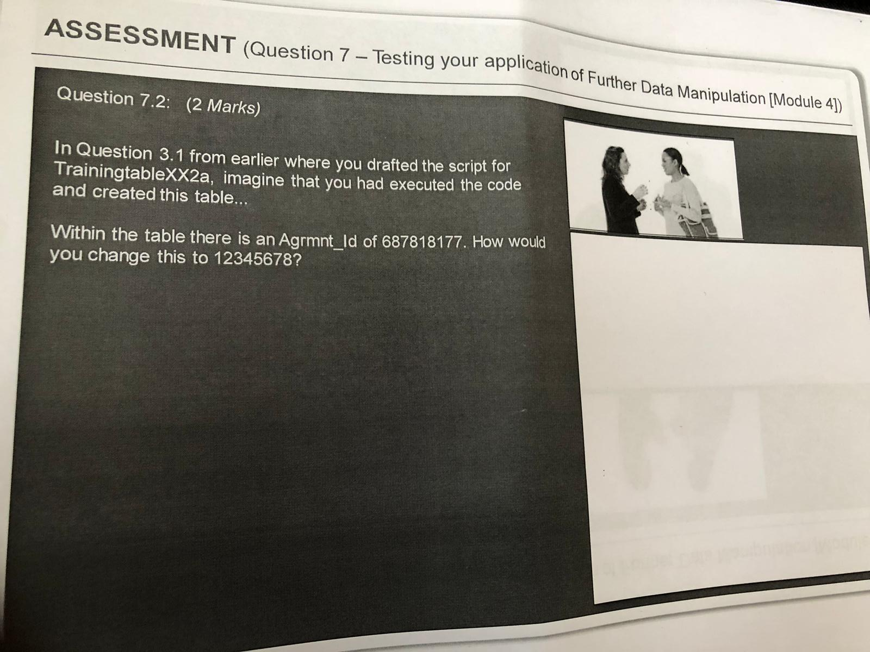

UPDATE CDM.TrainingtableEO2a

SET Agrmnt_Id = 12345678

WHERE Agrmnt_Id= 687818177;